1. Show that (𝐴∪𝐶)∩(𝐵∪𝐶)⊆(𝐴∩𝐵)∪𝐶

Proof: For any $x∈(A∪C)∩(B∪C)$, we have $x∈A∪C and x∈B∪C$. There are two possibilities, $x∈C$ and $x∉C$.

If $x∈C$, then $x∈\left(A∩B\right)∪C$ by the definition of union.

If $x∉C$, then $x∈A∪C$ implies $x∈A$, and $x∈B∪C$ implies $x∈B$. Hence $x∈A∩B$, which further implies $x∈\left(A∩B\right)∪C$.

Hence, for both $possibilities$, it holds that $x∈\left(A∩B\right)∪C$. Thus (𝐴∪𝐶)∩(𝐵∪𝐶)⊆(𝐴∩𝐵)∪𝐶.

1. Write each of the followings explicitly

a). $∅×\left\{1,2\right\}=∅$

b). $2^{\{1,2\}}×\left\{1,2\right\}=\left\{∅,\left\{1\right\},\left\{2\right\},\left\{1,2\right\}\right\}×\left\{1,2\right\}=\left\{\left(∅,1\right),\left(∅,2\right),\left(\left\{1\right\},1\right),\left(\left\{1\right\},2\right),\left(\left\{2\right\},1\right),\left(\left\{2\right\},2\right),\left(\left\{1,2\right\},1\right),\left(\left\{1,2\right\},2\right)\right\}.$

1. Let $f:A↦B$. Show that the following relation $R$ is an equivalence relation on $A$: $\left(a,b\right)∈R$ if and only if $f\left(a\right)=f(b)$.

Proof: Reflexive: since $f\left(a\right)=f(a)$, we know that $\left(a,a\right)∈R$ for any $a∈A$. Hence $R$ is reflexive.

Symmetric: for any $\left(a,b\right)∈R$, we know $f\left(a\right)=f(b)$, hence $f\left(b\right)=f(a)$, which implies $\left(b,a\right)∈R$. Hence $R$ is symmetric.

Transitive: if $\left(a,b\right)∈R$, $\left(b,c\right)∈R$, then we know that $f\left(a\right)=f(b)$, and $f\left(b\right)=f(c)$. Hence $f\left(a\right)=f(c)$, which means $\left(a,c\right)∈R$. Hence, $R$ is transitive.

1. Let $R_{1}$ and $R_{2}$ be any two partial orders on the same set $A$. Show that $R_{1}∩R_{2}$ is a partial order.

Proof: Reflexive: for any $a∈A$, we have $\left(a,a\right)∈R_{1}$ and $\left(a,a\right)∈R_{2}$ since $R_{1}$ and $R_{2}$ are reflexive. Hence, $\left(a,a\right)∈R_{1}∩R_{2}$, which means $R_{1}∩R_{2}$ is reflexive.

Anti-symmetric: if $\left(a,b\right)∈R_{1}∩R_{2}$, then we know $\left(a,b\right)∈R_{1}$ and $\left(a,b\right)∈R_{2}$. Since $R_{1}$ and $R_{2}$ are antisymmetric, we have $\left(b,a\right)∉R_{1}$ and $\left(b,a\right)∉R_{2}$. Hence $\left(b,a\right)∉R_{1}∩R_{2}$, which means $R_{1}∩R_{2}$ is anti-symmetric.

Transitive: if $\left(a,b\right)∈R_{1}∩R_{2}$, $\left(b,c\right)∈R_{1}∩R_{2}$, then we have $\left(a,b\right)∈R_{1}$, $\left(b,c\right)∈R_{1}$ and $\left(a,b\right)∈R_{2}$, $\left(b,c\right)∈R_{2}$. Since $R_{1}$ and $R_{2}$ are both transitive, we have $\left(a,c\right)∈R_{1}$ and $\left(a,c\right)∈R_{2}$. Hence $\left(a,c\right)∈R_{1}∩R_{2}$, which means $R_{1}∩R_{2}$ is transitive.

1. Show that any function from a finite set to itself contains a cycle.

Proof: Let the function be $f: A↦A$ for some finite set $A$. Since $A$ is a finite set, let $\left|A\right|=c$ for some $c∈N$.

We define functions $f^{\left(1\right)}\left(x\right)=f(x)$, and $f^{\left(k\right)}(x)=f(f^{\left(k-1\right)}(x))$ for $x∈A$ and $k∈N$.

Pick an arbitrary $a∈A$, and consider the sequence of $c+1$ elements $a,f\left(a\right),f\left(f\left(a\right)\right),⋯,f^{\left(c+1\right)}(a)$. Since $f^{\left(k\right)}\left(a\right)∈A$, these $c+1$ elements can take at most $c$ distinct values. By Pigeonhole principle, there exist some $1≤i<j≤c+1$ such that $f^{\left(i\right)}\left(a\right)=f^{\left(j\right)}(a)$. Hence, vertices $f^{\left(i\right)}\left(a\right),f^{\left(i+1\right)}\left(a\right),⋯,f^{\left(j\right)}(a)$ form a cycle.

1. Show that in any group of at least two people there are at least two persons that have the same number of acquaintances within the group. (Assuming acquaintance is bi-direction).

Proof: Suppose on the contrary that there exists a group of $k≥2$ people such that any two people have different number of acquaintances within the group. Index the $k$ people arbitrarily as $A_{1},A_{2},⋯A_{k}$, and let the number of acquaintances of $A_{i}$ be $a_{i}∈\{0,1,⋯,k-1\}$. By our assumption $a_{i}≠a_{j}$ for any $i≠j$.

We first claim that $\left\{a_{1},a_{2},⋯,a_{k}\right\}=\{0,1,⋯,k-1\}$, that is, $a_{1},a_{2},⋯,a_{k}$ is a permutation of $0,1,⋯,k-1$. Suppose the claim is not true, then $a_{1},a_{2},⋯,a_{k}$ only takes at most $k-1$ distinct values. Then by pigeonhole principle there exist some $i≠j$ such that $a_{i}=a_{j}$, which is a contradiction to our assumption. Hence, the claim is true, $\left\{a_{1},a_{2},⋯,a_{k}\right\}=\{0,1,⋯,k-1\}$.

According to the claim above, there exists some person, say, $A_{i}$ who has no acquaintance, and some person, say, $A_{j}$ who knows everyone else. However, this is impossible since acquaintance is bi-directional, the person $A_{j}$ who knows everyone else should also know $A_{i}$, which means $A_{i}$ knows at least one other person, contradicting to the fact that $A_{i}$ has no acquaintance. Hence, there does not exist a group of $k≥2$ people such that any two people have different number of acquaintances within the group, i.e., in any group of at least two people there are at least two persons that have the same number of acquaintances within the group.

1. * Show that there is no bijection between $S$ and $2^{S}$.

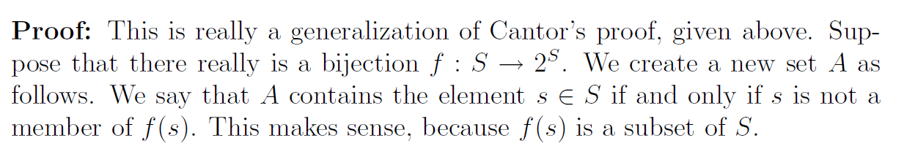

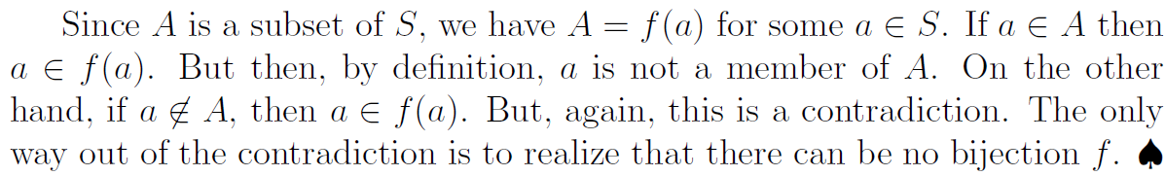

1. If $x∈{\left\{a,b\right\}}^{*},ax=xa$, show $x=a^{n}$ for some $n∈N$

Proof. Suppose on the contrary that $x≠a^{n}$ for any $n∈N$, then $b$ is a substring of $x$. Let $x=a^{m}bu$ for some $u∈{\left\{a,b\right\}}^{*}$, and $m∈N$. (Note this expression specifies the location of the first occurrence of “b” in the string of $x$, which is after $m$ copies of “a”). Since $ax=xa$, we have $a^{m+1}bu=a^{m}bua$. This is impossible because “b” occurs after $m+1$“a”s, but on the right string “b” occurs after $m$“a”s.

1. *Show that there does not exist string $x∈{\left\{a,b\right\}}^{*}$ such that $ax=xb$.*

Proof: Prove by induction on the string length.

Base case. If $\left|x\right|=0$, then $x=e$. Obviously $ae≠eb$.

Suppose the statement is true for all strings $x$ such that $\left|x\right|≤k$. We prove it for an arbitrary string $x$ such that $\left|x\right|=k+1$. We write $x=va or vb$ for some $\left|v\right|=k$, that is, $v$ consists of the first $k$ symbols from $x$.

If $x=vb$, then by $xa=ax$ we have $vba=vab$, which is impossible since the left string ends with a, and the right string ends with b.

If $x=va$, then by $xa=ax$ we have $vaa=ava$, which implies $va=av$. Since the induction hypothesis states that *there does not exist string $x∈{\left\{a,b\right\}}^{*}$ such that $ax=xb$ for any string $\left|x\right|≤k$,* we know there $va=av$ cannot be true.

Summarizing the above two cases, we know $xa≠bx$ for any string $x$ of length $k+1$. Hence, the statement is true for all strings $x$.

1. Write the regular expression for the following sets
   1. All strings over $\{a,b\}$ that are odd in length
 $${\left(a+b\right)}^{}{\left(\left(a+b\right)\left(a+b\right)\right)}^{*}$$

  2. All strings over $\left\{a,b\right\}$ that end with $bb$
$${\left(a+b\right)}^{*}bb$$

2. Construct a Deterministic Finite Automata accepting each of the following:

2.1 {$w∈{\left\{a,b\right\}}^{*}:w has abab as a substring$}

2.2 {$w∈{\left\{a,b\right\}}^{*}:w has neither aa nor bb as a substring$}

See homework solution.

1. Describe informally the languages accepted by the deterministic finite automata shown below:

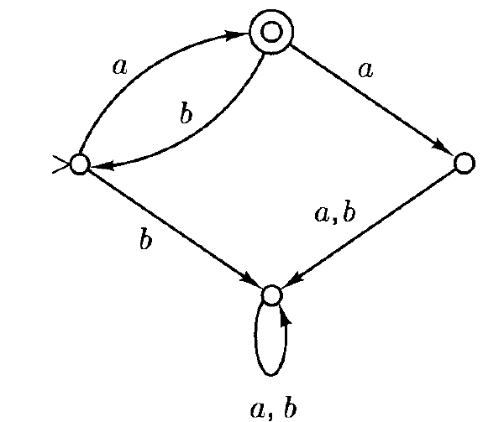

Answer: $a{\left(ba\right)}^{*}$

*Continued*

1. Construct a Deterministic Finite Automata accepting each of the following:

2.3 {$w∈{\left\{a,b\right\}}^{*}:each "a" in w is immediately preceded by a "b"$}

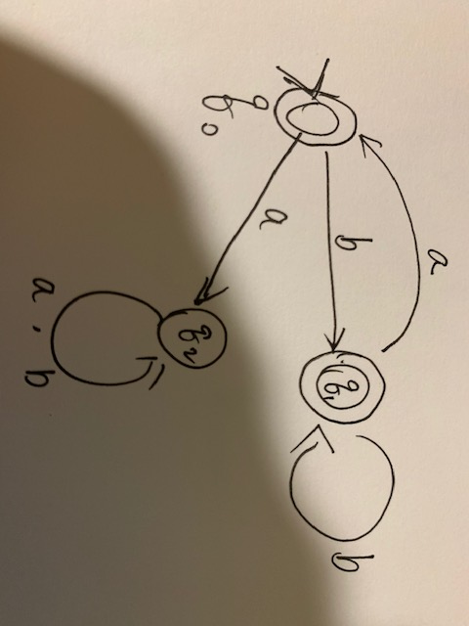

1. Describe informally the languages accepted by the deterministic finite automata shown below:

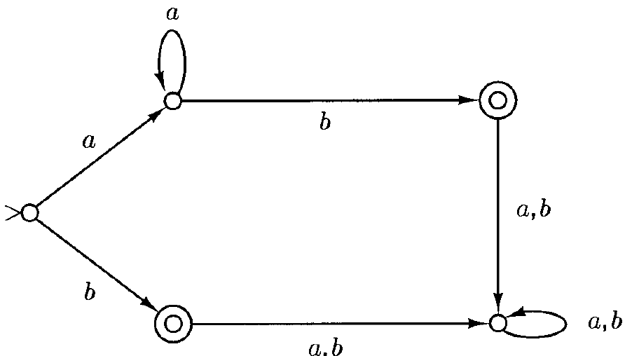

$$a^{*}b$$

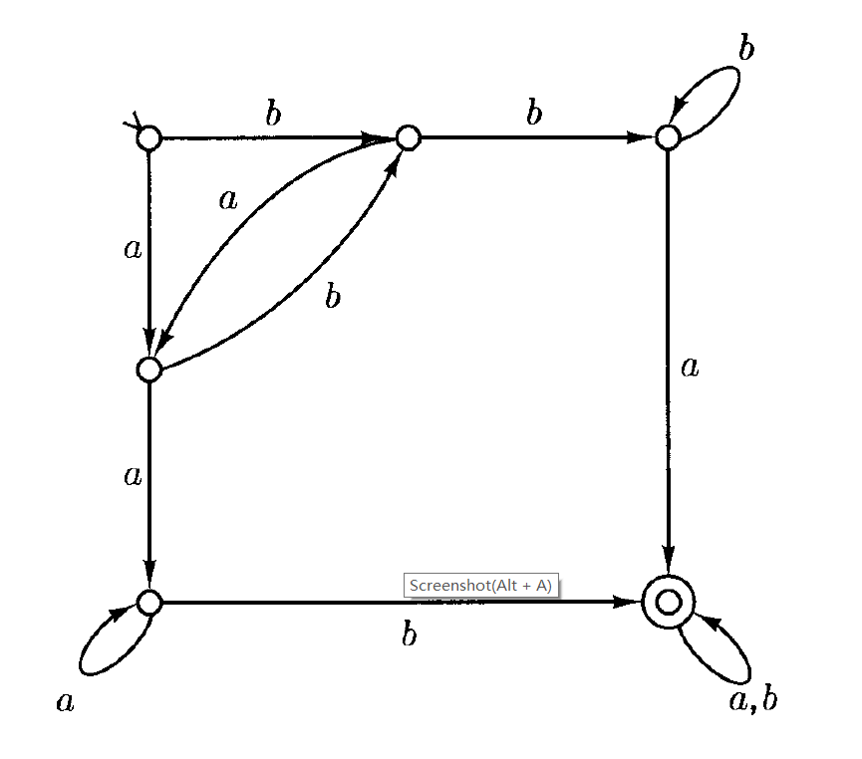

All strings containing $aab$ or $bba$ as a substring

1. Draw a state diagram for nondeterministic finite automata that accepts the following languages

${(\left(ab\right)}^{*}{\left(ba\right)}^{*})+{aa}^{*}$

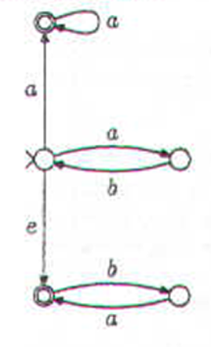

$${\left(ba+b\right)}^{*}+{\left(bb+a\right)}^{*}$$

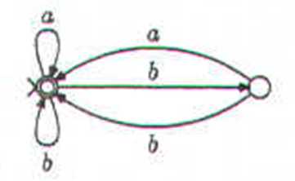

1. Give the regular expression for the language accepted by the following non-deterministic finite automaton:

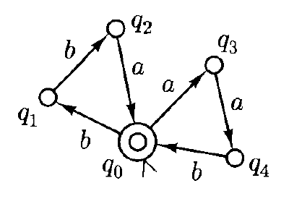

$${\left(bba+aab\right)}^{*}$$

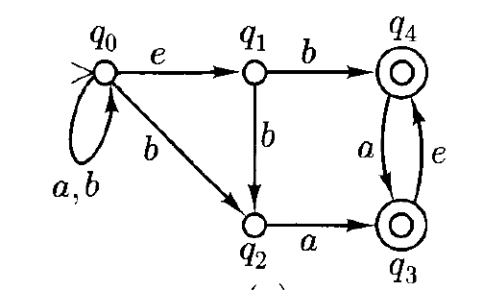

$${\left(a+b\right)}^{*}ba^{*}+{\left(a+b\right)}^{*}baa^{*}$$

1. Construct a deterministic finite automaton which accepts the same language as the above non-deterministic finite automata.

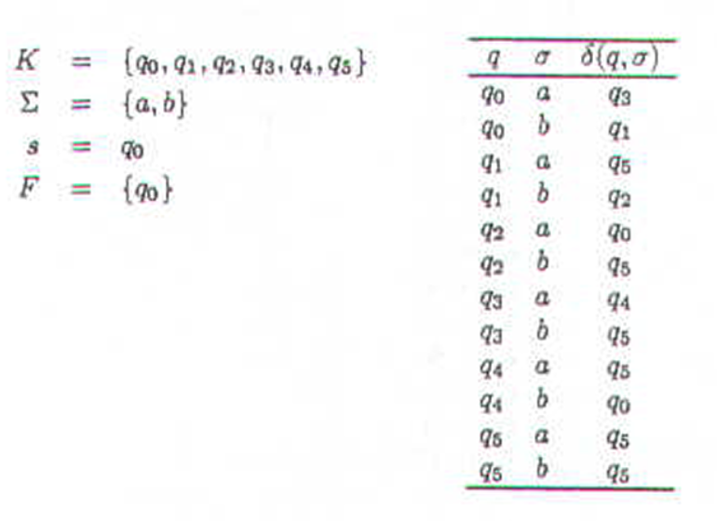

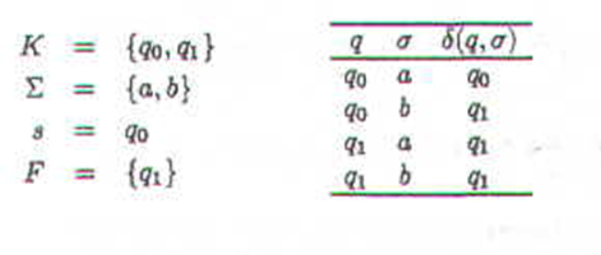

Questions marked with (*) are more challenging questions that help you better understand the contents. Please take notes in class.

1. (*) Define a language $L$ to be finite if there is some integer $k$ such that for any string $w$, whether $w∈L$ depends only on the last $k$ symbols of $w$.

17.1. Give any example of a definite language.

17.2 Give a more formal definition of a definite language

17.3 Consider all definite languages with $\{a,b\}$ as the alphabet. Show that any such language can be accepted by a finite automaton.

17.4 Show that the union of two definite languages over the same alphabet is also a definite language.

17.5 Show that the complement of a definite language is also a definite language.

17.6 Show that the concatenation of two definite language may not be a definite language

Blackboard argument

1. (*) Let $L$ be some language, define:

$Pref\left(L\right)=\left\{w∈Σ^{*}:x=wy for some x∈L, y∈Σ^{*}\right\}$ (the set of prefixes of L)

$Suf\left(L\right)=\left\{w∈Σ^{*}:x=yw for some x∈L, y∈Σ^{*}\right\}$ (the set of suffixes of L)

$Subseq\left(L\right)=\left\{w_{1}w_{2}⋯w_{k}∈Σ^{*}:k∈N, there exists x=x_{0}w_{1}x_{1}w_{2}⋯w_{k}x_{k} ∈L\right\}$ (the set of subsequences of L)

Show that each of the above is regular if $L$ is regular.

Blackboard argument

1. Prove that $\{a^{n}ba^{m}ba^{m+n}:n,m≥1\}$ is not regular.

Proof: Suppose $L=\{a^{n}ba^{m}ba^{m+n}:n,m≥1\}$ is regular. According to the pumping theorem, there exists some constant $N_{0}$ such that if $\left|a^{n}ba^{m}ba^{m+n}\right|≥n_{0}$, then there exist some $x,y,z$ such that $a^{n}ba^{m}ba^{m+n}=xyz$ such that $\left|xy\right|≤n_{0}, \left|y\right|≥1,$ and $xy^{i}z∈L$ for any $i∈N$.

Take $n=n_{0},m=1$, then we have $a^{n_{0}}baba^{1+n_{0}}=xyz$ such that $\left|xy\right|≤n_{0}, \left|y\right|≥1,$ and $xy^{i}z∈L$ for any $i∈N$. Since $\left|xy\right|≤n_{0}, \left|y\right|≥1,$ we know $x=a^{α},y=a^{β}$ for some $β≥1$. Hence $xy^{i}z=a^{α+iβ}a^{n_{0}-α-β}baba^{1+n_{0}}∈L$ for any $i≥0$ by pumping theorem. However, taking $i=2, a^{α+2β}a^{n_{0}-α-β}baba^{1+n_{0}}=a^{n_{0}+β}baba^{1+n_{0}}$. It is easy to see that $n_{0}+β+1>n_{0}+1$ as $β≥1$, whereas $a^{n_{0}+β}baba^{1+n_{0}}∉L$, contradicting that $xy^{i}z=a^{α+iβ}a^{n_{0}-α-β}baba^{1+n_{0}}∈L$ for any $i≥0$. Hence, $L$ is not regular.

1. Show that each of the following is or is not a regular language. The decimal notation for a number is the number written in the usual way, as a string over the alphabet $\{0,1,⋯9\}$. For example, the decimal notation for 13 is a string of length 2. In unary notation, only the symbol “I” is used; thus 5 would be represented asIIIII in unary notation.

(For regular languages, write down its regular expression or describe the automata accepting it; for languages that are not regular, prove it using pumping lemma)

* 1. { is the unary notation for a number that is a multiple of 7}
  2. (*) { $w: w$ is the decimal notation for a number that is a multiple of 7}
  3. (*) $L=$ { $w: w$ is the unary notation for a number $n$ such that there is a pair $p, p+2$ of twin prime numbers, both greater than $n$}. Twin prime conjecture, also known as Polignac's conjecture, in number theory, asserts that there are infinitely many twin primes, or pairs of primes that differ by 2. If the conjecture is true, is $L$ regular? If the conjecture is wrong, is $L$ regular?
  4. { $w: w$ is the unary notation for ${10}^{n},n ≥1$}

21.1 Which of the following statements is **correct**? (D)

a). If $A$ and $A∘B$ are both regular languages, $A∩$

$B=∅$, then $B$ is also a regular language

$A=a^{*}, B=\{a^{i}b^{j}:i≠j,i,j≥1\}$

b). If $A$ and $A∩B$ are both regular languages, then

$B$ is also a regular language

c). If $A$ and ${\left(A∘B\right)}^{*}$ are both regular languages,

$A∩B=∅$, then $B$ is also a regular language

d). If $A$ and $A∪B$ are both regular languages,

$A∩B=∅$, then $B$ is also a regular language

$$B=\left(A∪B\right)∩\overline{A}$$

21.2 Let $L$ be a regular language over alphabet $Σ$. Which of the followings is **correct**? (B)

a). It is possible that any subset of $L$ is not regular

b). All strings of $L$ that has an even length is regular

c). It is possible that for any $A⊆Σ^{*}$, $L⊆A$, $A$ is

not regular

d). The set of all strings that is formed by the

concatenation of strings in $L$ may be nonregular